### **Resistor Color Code Chart**

Resistors are marked with colored bands that indicate their resistance value. Here's a quick reference for the **color code chart** used on resistors:

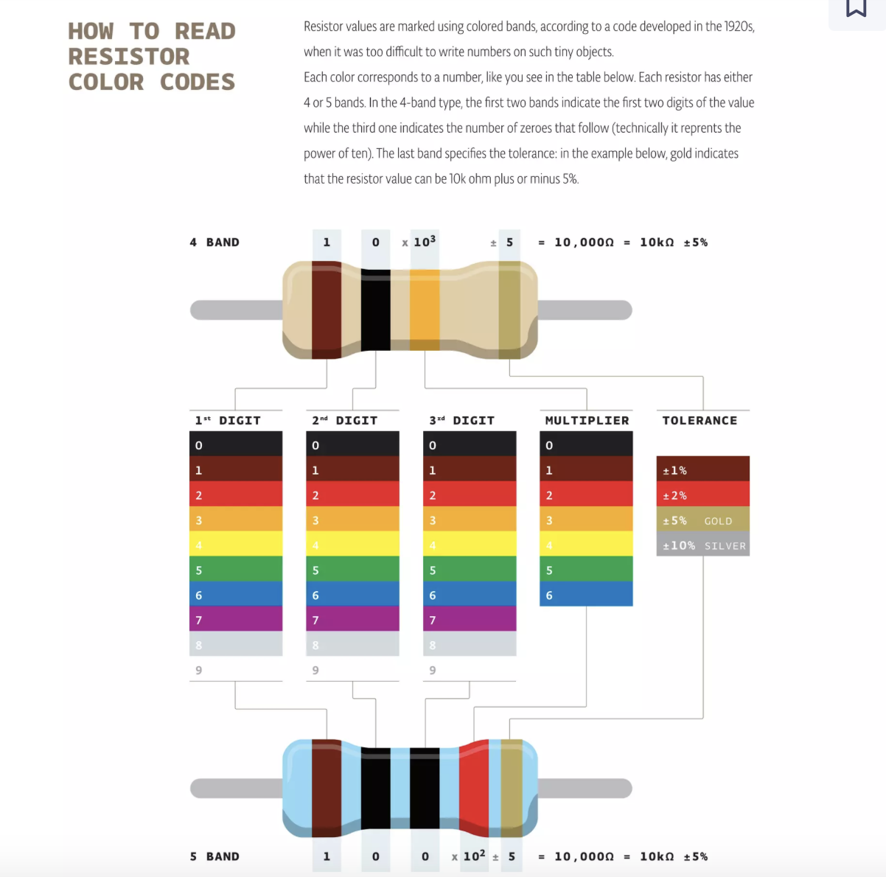

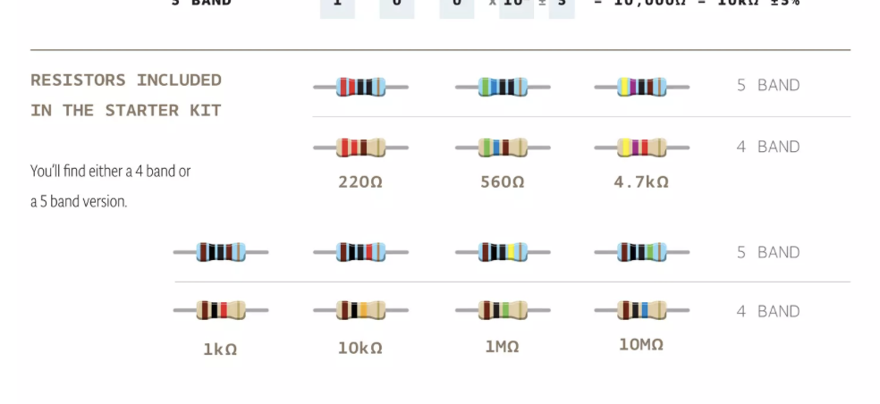

| **Color** | **Digit** | **Multiplier** | **Tolerance** |
| --- | --- | --- | --- |
| Black | 0 | ×1 |  |
| Brown | 1 | ×10 | ±1% |
| Red | 2 | ×100 | ±2% |
| Orange | 3 | ×1,000 |  |
| Yellow | 4 | ×10,000 |  |
| Green | 5 | ×100,000 | ±0.5% |
| Blue | 6 | ×1,000,000 | ±0.25% |
| Violet | 7 | ×10,000,000 | ±0.1% |
| Gray | 8 |  | ±0.05% |
| White | 9 |  |  |
| Gold |  | ×0.1 | ±5% |
| Silver |  | ×0.01 | ±10% |

### **How to Read a Resistor Color Code**

A resistor typically has **4 or 5 colored bands**:

1. **First band**: The first digit.
2. **Second band**: The second digit.
3. **Third band**: The multiplier (how many zeros to add).
4. **Fourth band**: The tolerance (optional, indicates how much the actual value can vary from the labeled value).
5. **Fifth band** (if applicable): Tolerance or temperature coefficient.

#### **Example:**

* **Red, Violet, Brown, Gold**:
  + **Red (2)**, **Violet (7)**, **Brown (multiplier ×10)**
  + **27 × 10 = 270 ohms** with **±5% tolerance** (Gold).

So, the resistor has a value of **270 ohms ±5% tolerance**.

### **Common Resistor Values for Arduino Projects**

Arduino Uno boards typically work with resistors in the following ranges for common components (e.g., LEDs, pull-up/pull-down resistors, etc.):

* **220Ω** – Commonly used for **LEDs** (to limit current).
* **330Ω** – Common for **LEDs** and small current limiting.
* **1kΩ** – Used for **pull-up or pull-down resistors** and **LEDs**.
* **10kΩ** – Common for **pull-up or pull-down resistors** in digital circuits.
* **100kΩ** – Used in analog circuits, for **sensors** or **voltage dividers**.
* **1MΩ** – Used in high-impedance circuits (e.g., analog sensors).

### **Resistor Sizing for Arduino**

* **LEDs**: To prevent damaging an LED, use a **current-limiting resistor**. The value depends on your **Arduino’s 5V output**, and the **LED's forward voltage** and **desired current**.  
  For example, with a **5V supply** and a typical **LED** with a **2V forward voltage** and **20mA current**, use:
* R=ILED​Vsupply​−VLED​​=0.02A5V−2V​=150 ohms  
  In practice, you'll likely use the nearest standard resistor, which is **220Ω**.

### **Using Resistors with the Arduino Uno:**

1. **Current Limiting**: When driving an LED, you'll often use a **220Ω or 330Ω resistor** to limit the current, depending on the LED's characteristics.
2. **Pull-up/Pull-down Resistors**: **10kΩ** resistors are commonly used in circuits for **buttons** or **sensors** where a pin needs to be either pulled high or low when the input device is not actively driving it.
3. **Voltage Dividers**: For sensors that output an analog voltage, resistors like **10kΩ**, **100kΩ**, or **1MΩ** are used to create voltage dividers.

### **Summary:**

If you're working with an **Arduino Uno** and need resistors for common tasks, here's a quick list of typical values to keep on hand:

* **220Ω** – LED current-limiting
* **330Ω** – LED current-limiting
* **1kΩ** – Pull-up/down, general use
* **10kΩ** – Pull-up/down, analog sensors
* **100kΩ** – Voltage dividers
* **1MΩ** – High impedance applications

If you're working on specific circuits, you may need other resistor values based on the components you're using.